**RESULTS OBTAINED FOR FHI INFECTED**

**Case 1:**

**Step 1 : Read the image( FHI infected)**

rgb = imread("C:\Users\shyam\Desktop\EYE\fus'\1692876676788.jpg");

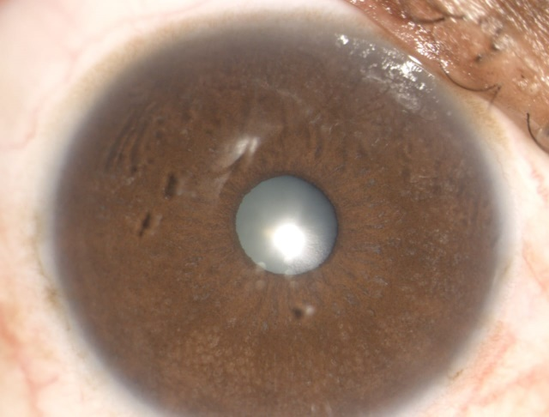

**Step 2 : Convert the image to gray scale image**

gray = rgb2gray(rgb);

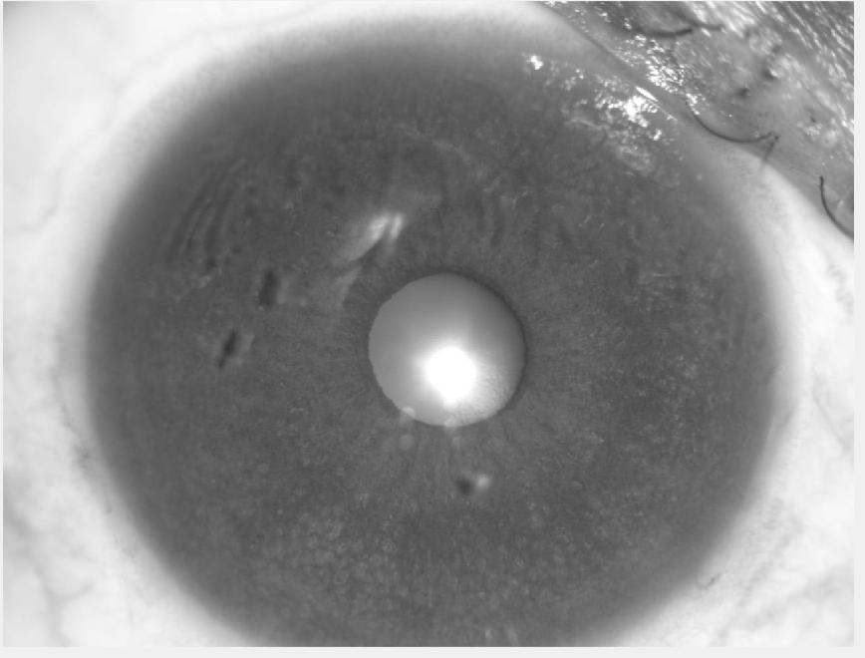

**Step 3 : Apply median filter to remove any noise**

gray = medfilt2(gray, [3 3]);

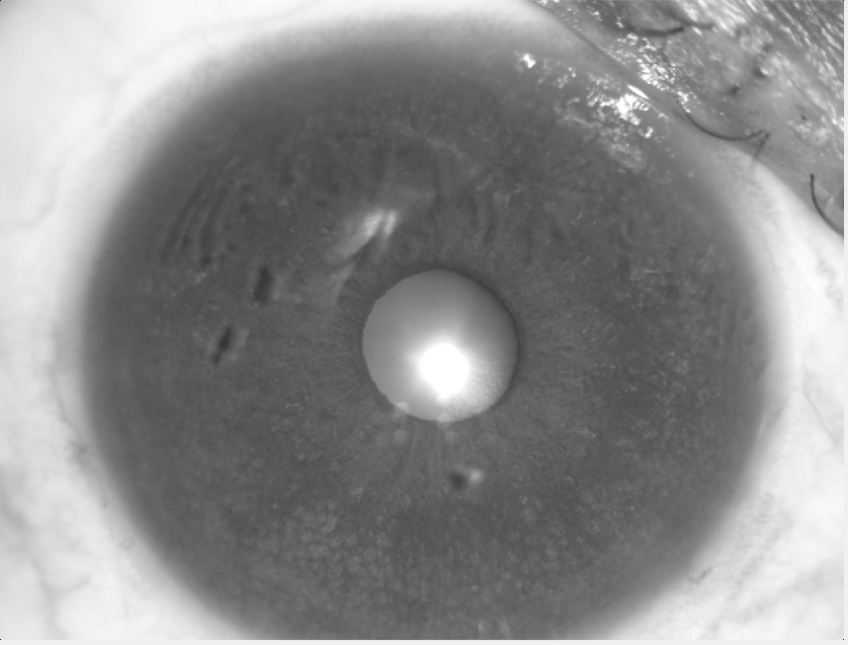

**Step 4 : Perform thresholding to identify changes in intensity levels**

BW = gray > 102;



**Step 5 : Perform edge detection using Canny edge detection algorithm. Link the edges**

edges = edge(gray, "canny");

b = bwmorph(edges, 'bridge');

se = strel('line', 4, 180);

b = imdilate(b, se);

imshow(b);

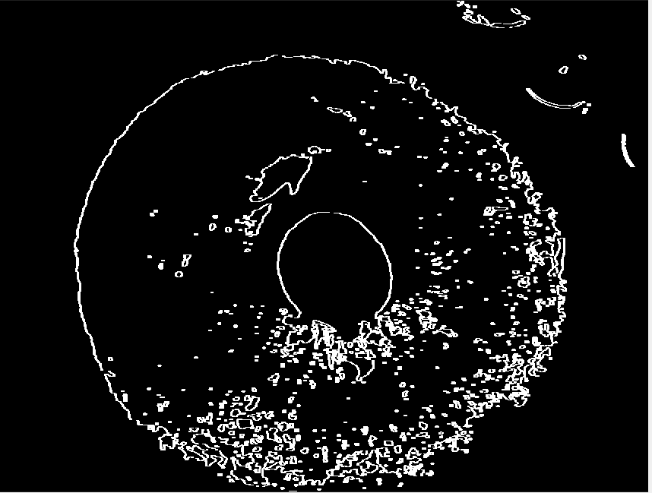

***End result of Case 1 FHI infected***

**Case 2:**

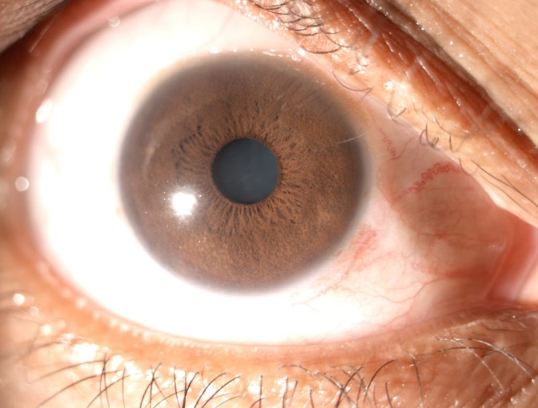

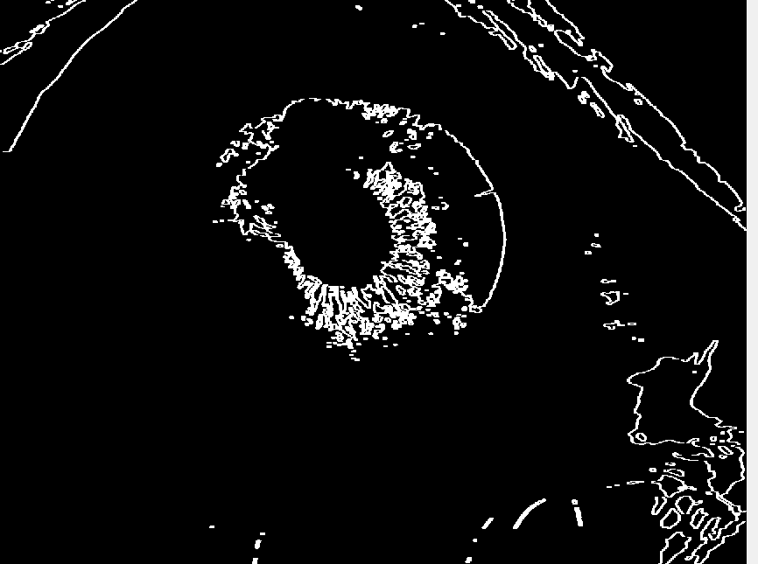

***End result of Case 2 FHI infected***

**RESULTS OBTAINED FOR NORMAL EYE**

**Case 1:**

rgb=imread("C:\Users\celsh\Downloads\fwdnormal (1)\1692876884795.jpg")

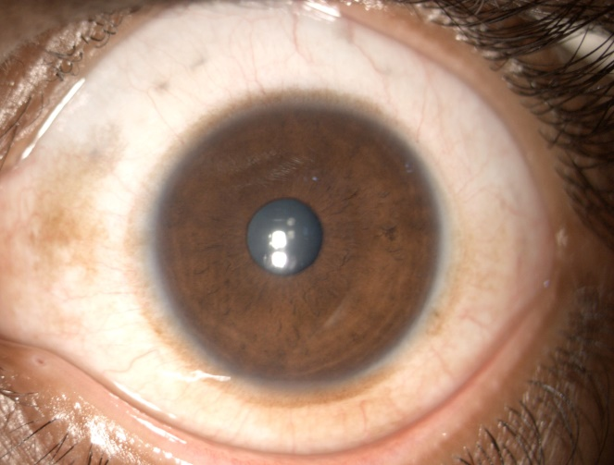

gray = rgb2gray(rgb);

gray = medfilt2(gray, [3 3]);

BW = gray > 102;

edges = edge(BW, "canny");

b = bwmorph(edges, 'bridge');

se = strel('line', 4, 180);

b = imdilate(b, se);

imshow(b);

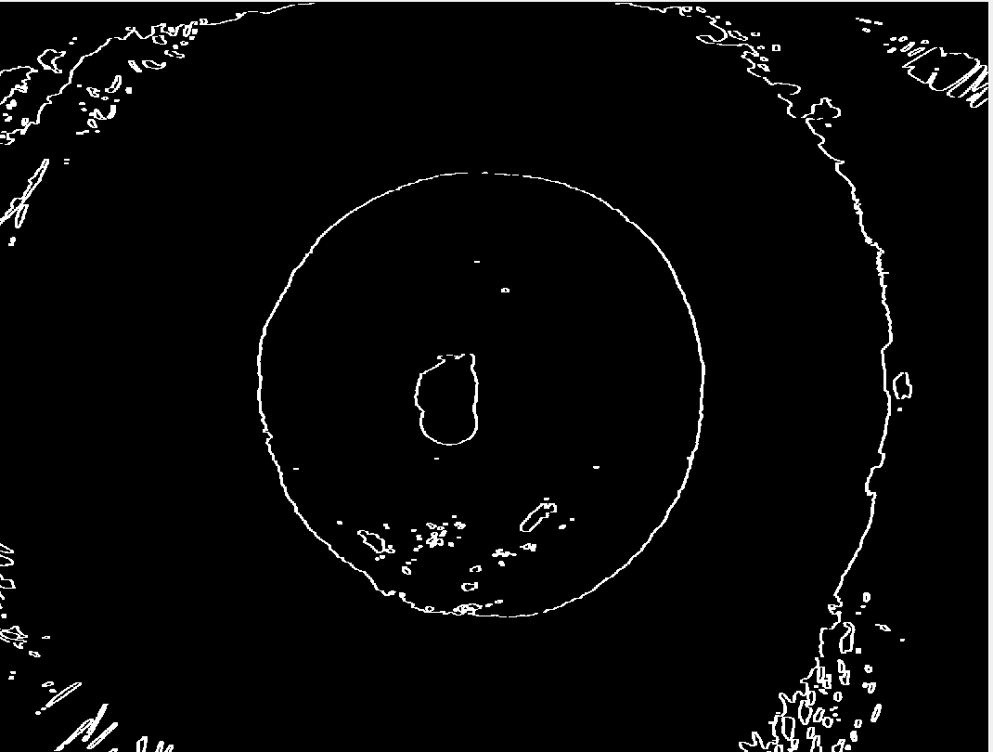

***End result of Case 1 normal***

**Case 2:**

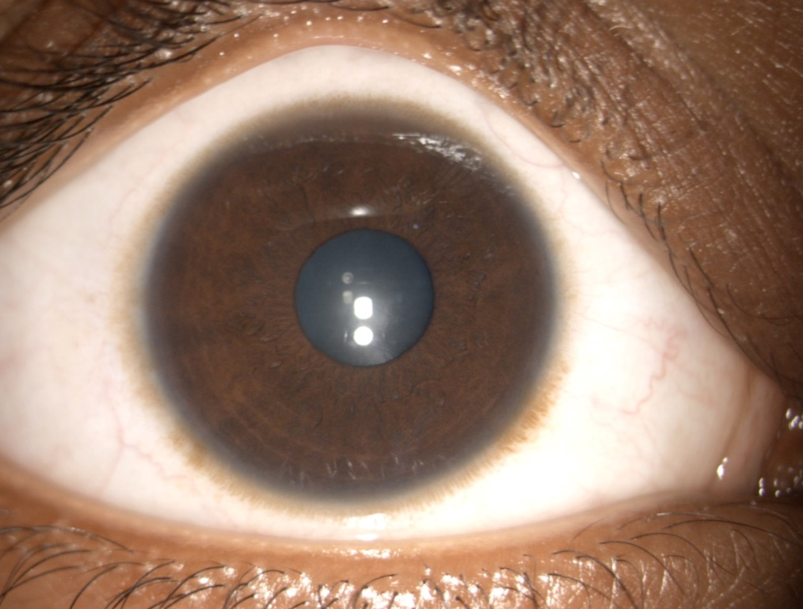

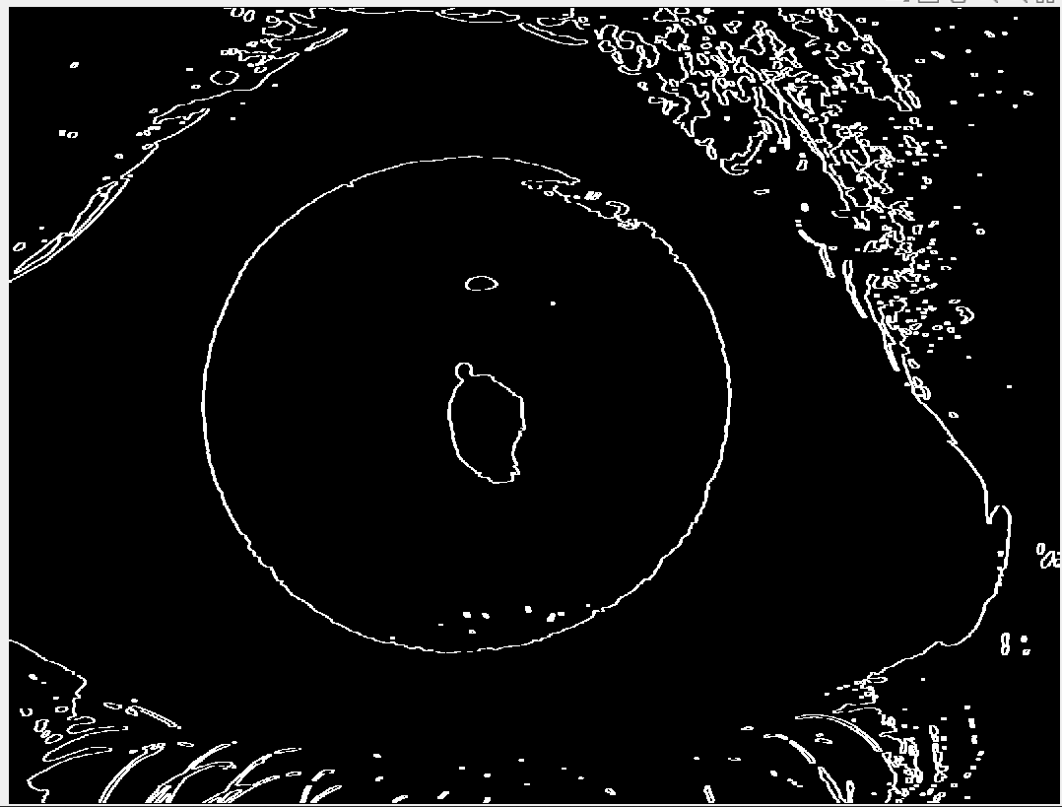

***End result of Case 2 normal***

**INFERENCE :**

1. The dataset given was Normal : 15 images; Abnormal : 16 images

Using this dataset, it is impossible to apply deep learning strategies as the data is insufficient to make the model to learn.

1. Conventional image procehssing steps were deployed to identify FHI infected eye

Results of FHI infected: The final images obtained showed **many small edges within the iris.**

Results of Normal: The final images obtained showed **less or no edges within the iris.**